**Report**

1. **Given the provided data, what are three conclusions that we can draw about crowdfunding campaigns?**

* Crowdfunding campaigns generally have a 57% success rate. The theatre, film and video and music categories represent 70% of the total Crowdfunding campaigns in the sample, with an average success rate of 57%.

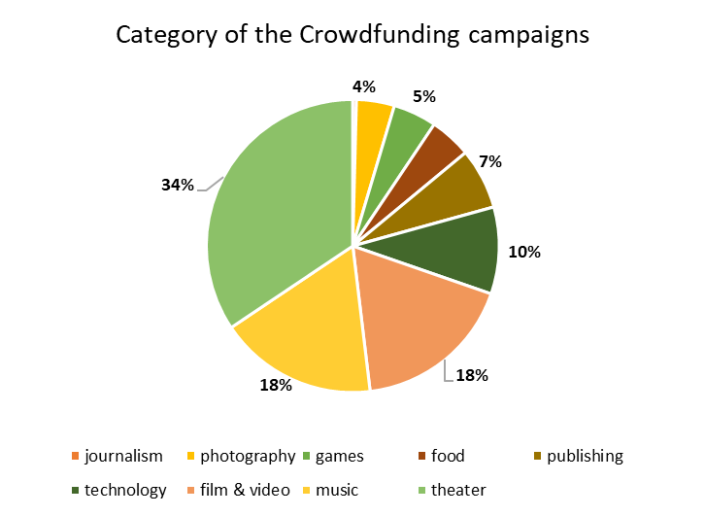

* June and July are the months where crowdfunding campaigns are most successful. January, August and December are the months where the chances of failure of a crowdfunding campaign increase.

* The US is the country with the highest volume of crowdfunding campaigns and the GB is the country with the greatest success in crowdfunding campaigns. However, AU is the country where the average donation is higher.

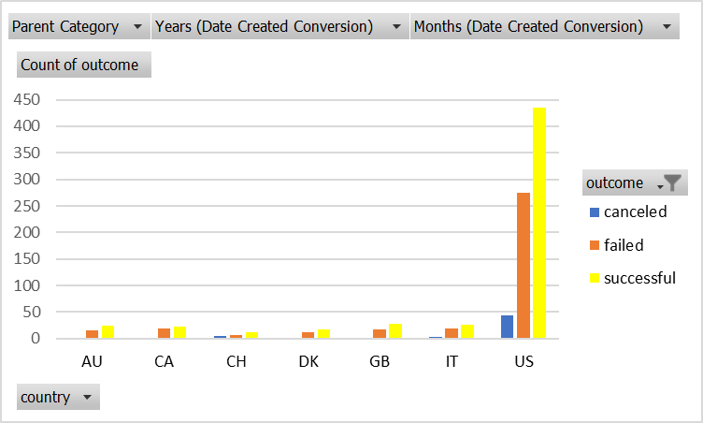

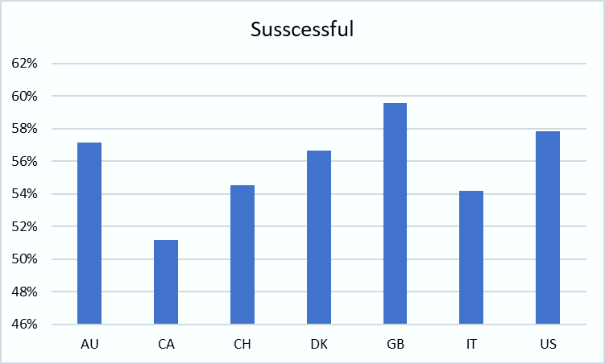

1. **What are some limitations of this dataset?**

The dataset does not provide more detailed information that allows for a deeper analysis. Some of the information that is missing is:

* Demographics like Age, gender of the population that donates to the crowdfunding campaigns.
* Location within the country (city, town, among others)
* Educational level of the people who make the donations and average annual income.

1. **What are some other possible tables and/or graphs that we could create, and what additional value would they provide?**

* Table by country and average donation, in order to find in which country people, donate more money to crowdfunding campaigns.